1. **Agenda**:
   1. How to declare Enum and Usages?
2. How to declare variable of Enum Type and initialize its value?  
   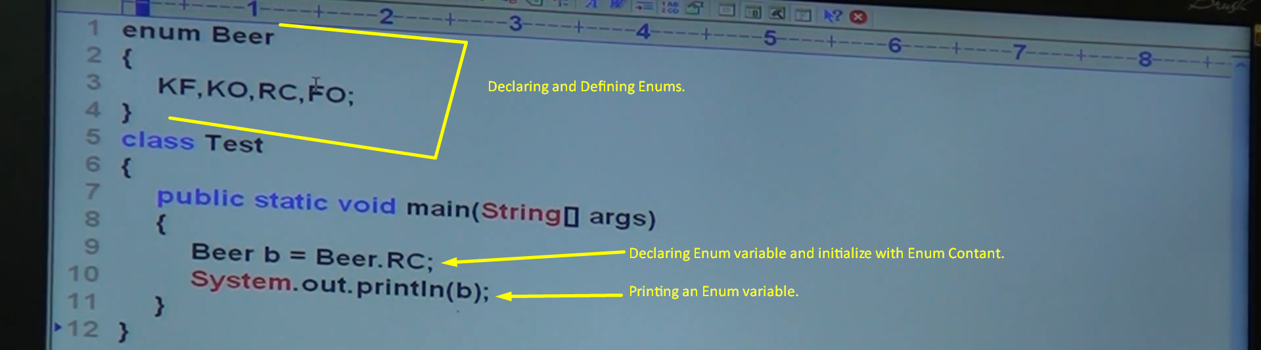  
     
   
3. What all places we can declare enum?
   1. Outside of class.
   2. Inside a class like inner class.
   3. Inside a method: Such inner classes are called method local inner classes.   
      **NOTE**: But we can not declare enum inside a method otherwise Compile time error.  
      
4. Now which modifiers are allowed for a class if we declare outside a class or inside a class?
   1. Outside a class:
      1. Public, <default>, final, abstract, strictfp
   2. Inside a class:
      1. Public, <default>, final, abstract, strictfp
      2. Private
      3. Protected
      4. Static.
5. Now which modifiers are allowed for an enum if we declare outside a class or inside a class?
   1. Outside a class:
      1. Public, <default>, strictfp
      2. Abstract and final.
   2. Inside a class:
      1. Public, <default>, final, abstract, strictfp
      2. Private
      3. Protected
      4. Static.
6. 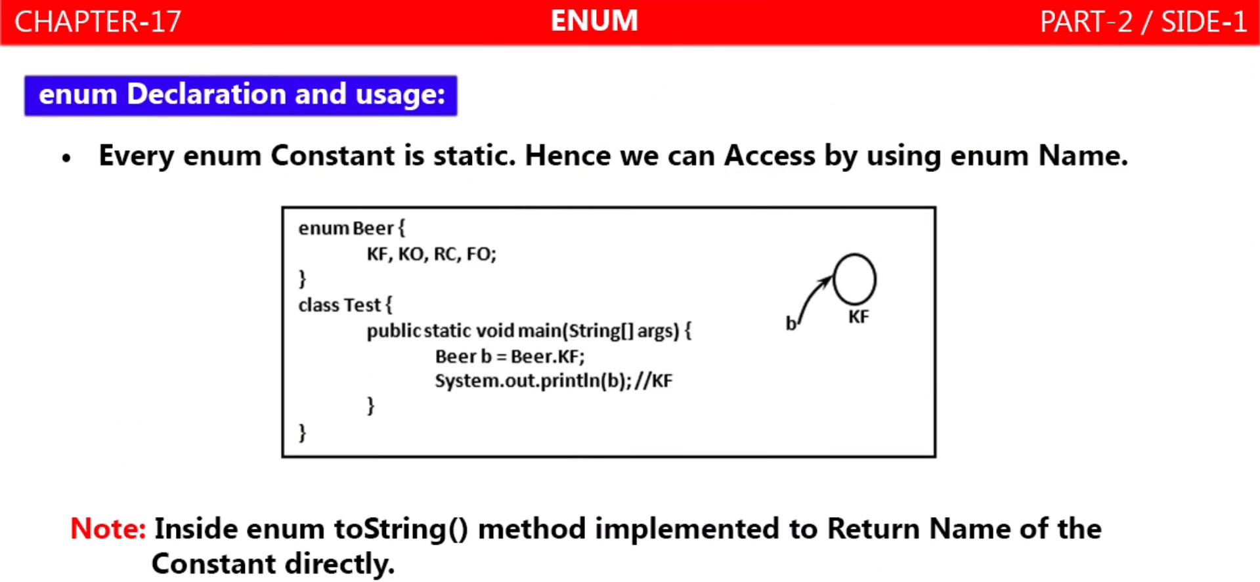
7. 